Employee Management System

High Level Requirements

1. The system should enable the admin to add the details of the new employees.
2. The system should provide the provision for the admin to delete the employees.
3. Updating the details of the employee by giving id, name and address.
4. The admin can view the details of the employee by giving their employee id.

Low Level Requirements

1. On entering the same Employee Id ,the system should provide an error message saying that Employee Id already exist.

Design Diagrams

Structural Diagrams

Behavioural Diagrams

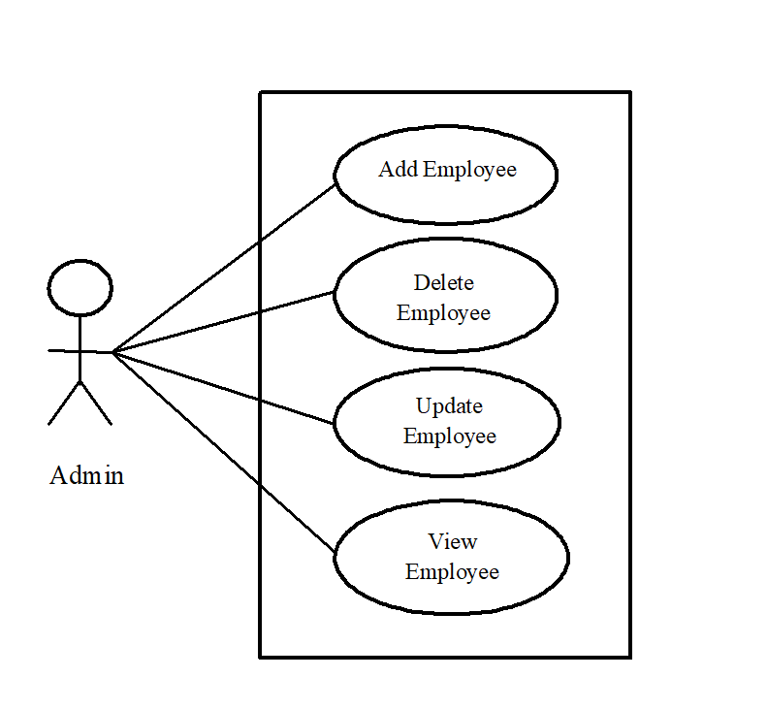

Use Case Diagram

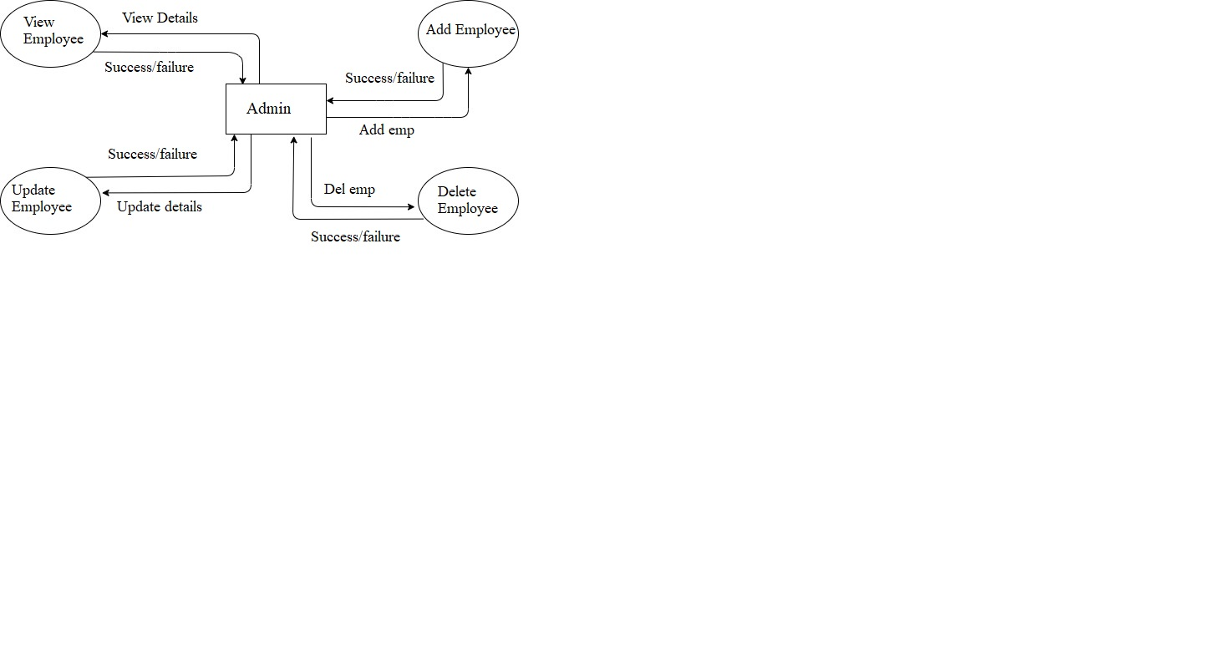

Data Flow Diagram

Test plan

|  |  |  |  |  |
| --- | --- | --- | --- | --- |
| Test ID | Description | Expected I/P | Expected O/P | Actual O/P |
| 1 | Adding the details of Employee such as id, name and address | Employee id-1  Name-Ram  Address-Mysuru  Salary-1000 | Employee added successfully message must be displayed |  |
| 2 | Adding the details of Employee such as id, name and address | On entering existing employee id. | Employee by this ID already exists message must be displayed. |  |
| 3 | Deletion of Employee | Employee Id-1 | Employee Deleted successfully message will be displayed. |  |
| 4 | Deletion of Employee | Invalid Employee Id | Could not find the Employee to delete message must be displayed |  |
| 5 | Updating the details of the Employee | Enter the details of the employee such as name ,address and salary. | Employee by ID is updated successfully to the database message will be displayed. |  |
| 6 | Updating the details of the Employee | On entering invalid Employee Id | No Employee by this id found to update |  |